|  |
| --- |
| Author! Ensure that your manuscripts should be completely grammatical error free. Do not form complex and lengthy sentences unless it is needed.  Title of the manuscript should be not less than 15 words |

**Antimicrobial activity of silver nanoparticles synthesized from fruit epicarp of *Glycosmis pentaphylla***

Author name, along with appropriate superscripts for indicating their affiliation

**Swapan Kumar Chowdhury1*, Nayan roy2 and Indrani mukherjee3**

1*Balurghat College, Department of Botany, Balurghat, Dakshin Dinajpur, West Bengal, India, PIN-733101*

Ensure presence of authors and their affiliation. The Author names should have suitable and respective superscript for their affiliations.

*2M. U. C. Women’s College, Department of Zoology, Ecology Research Unit Burdwan, West Bengal, India*

*3Indrani Mukherjee, M. Sc., Research scholar, Department of Botany, Balurghat College, Balurghat, Dakshin Dinajpur, West Bengal, India, PIN -733101*

**Abstract:** Our study aim is to characterize and assess the antimicrobial effect of silver nanoparticles (AgNPs) synthesized from the fruit epicarp of *Glycosmis pentaphylla* against few crops and human pathogens. Our study suggests a novel method for biosynthesis of silver nanoparticles from the epicarp of *Glycosmis pentaphylla.* The study confirms the ability of the fruit epicarp extract of *Glycosmis pentaphylla* for the biosynthesis of silver nanoparticles grown under *in-vitro* conditions. The green synthesis of AgNPs from (Ethyl alcohol) EtOH extracts of *Glycosmis* *pentaphylla* was performed through standard protocols. The synthesized AgNPs were confirmed by colour changes (green to brown) within <10 minutes and characterized by UV-visible spectral, SEM and TGA analysis (Scanning electron microscope, Thermal gravimetric analysis). Antimicrobial activities of the silver nanoparticles were performed by agar well diffusion method against crops pathogenic fungus and human pathogenic bacteria. The highest antifungal activities of silver nanoparticles were found against *Colletotrichum lindemuthianum* and *Alternaria alternata.* The antibacterial activity was measured through the zone of inhibition against *B. subtilis* (18 mm), *S. typhimurium* (17.33 mm), *S. mutans* (17 mm) and *E. coli* (17 mm). The antimicrobial potential of AgNPs was determined by minimum inhibitory concentration (MIC), minimum fungicidal concentration (MFC) and minimum bactericidal concentration (MBC) tested against human and plant pathogens. In addition, AgNPs displayed the signiﬁcant synergistic antibacterial effect when it combined with Streptomycin and Ciprofloxacin in the ratio of 1:1. This eco-friendly, biocompatible and sustainable phytofabrication approach of bioactive AgNP synthesis is a progressive step towards various applications to control few crops (Chilli, and Tomato) and human pathogens in near future.

**Keywords:** *Glycosmis pentaphylla,* fruit epicarp, silver nanoparticles, antimicrobial activity, synergistic effect

Keywords atleast should be 5-6 words (Specific to your study)

**1. INTRODUCTION**

The worldwide agricultural production gets compromised over the past few years due to crop pathogens. The harmful effects on fruits and vegetables of these pathogens have compromised the quality of the crops along with economical loss globally. The consumption rate of fruits and vegetables has increased up to 40% during the past few years. Every year, the amount of loss is approximately 20% of all fruits and vegetables1.The fresh fruits and vegetables are exposed to contamination by microorganisms, especially plant fungi from direct contact with soil, dust, water during harvesting or post harvesting2. Now a day’s the traditional antibacterial treatment against the growing resistance of human pathogenic bacterial strains has become a big challenge3. The microbial infection is a serious problem in the agriculture and healthcare sector worldwide. Therefore, it is needed to develop a new antimicrobial agents including different characteristics, such as eco-friendly, low toxicity, antimicrobial potency, and great compatibility. In this situation, nanoparticles (NPs) have accepted as alternative to chemical pesticides worldwide, due to their electrostatic attraction between positively charged NPs and negatively charged microbial cells, and a large surface to volume ratio, resulting in improved physicochemical properties and enhanced antimicrobial activities of the NPs4,5. The antibacterial and antifungal properties of NPs have recently been widely reported 6, 7, 8. The application of metal nanocomposites enhanced antimicrobial activity against multi drug resistance bacterial infection 9, 10, 11. The antibiotics could be more effective when combined with metal NPs conditions 12 as, NP-antibiotic conjugate could lower the amount of both dosages, which reduces noxiousness and increases antimicrobial properties. The various research areas like drug discovery, biomedical sciences, cosmetics, luminescence, and renewable energy technologies focus on novel properties of NPs which make them extremely versatile 13. Among the different types of metallic nanoparticles, silver nanoparticles are widely used because of their unique and remarkable properties, enhanced permeability, retention effect and antimicrobial activity 14, 15, 16. Therefore, the market value of AgNPs increased day by day due to this inherent property which extends the AgNPs applications as an antimicrobial agent in different arrays of products, such as soaps, plastics, food and textiles 17. The binding and absorption rate of the drug on patient cells increased due to the existence of protein caps on nanoparticles which also bind to the bacterial cell surface. The mode of action of AgNPs showed that it decreased the rate of bacterial cell permeability, cellular respiration, DNA and protein function inside the cell 18. Many researchers focus on numerous evidences of synthesis of different AgNPs and their antimicrobial activity but MIC, MBC and Synergistic effect against human pathogenic bacteria are rare. The modern age of nanotechnology, there is an ongoing competition to identify “green” pathways to synthesize metallic nanoparticles using biological resources, mainly plant. There are several scopes for improving the green pathway for a single step rapid synthesis of AgNPs at room temperature by different modifications. In an earlier report, AgNPs were synthesized by the reduction of aqueous Ag+ ions using unexploited weed resources (*Ipomoea, Enhydra*, and *Ludwigia*) and sunflower (*H. annuus*)19,20. There is a scope for improvement in bio-based methods for single step rapid synthesis of metallic Nps at room temperature by modulating their size. The fruit epicarp of *Glycosmis pentaphylla* has many medicinal and reducing properties which have been used for synthesizes of AgNPs by the reduction of AgNO3 by using aqueous extract of the fruit epicarpat room temperature within 72hrs. However, the synthesis of AgNPs using such plant constituents has not yet been fully studied along with their antimicrobial activity. The nanoparticles synthesized from various plant parts used to control different plant and animal disease causing microorganisms. There is numerous evidence of the synthesis of different AgNPs but the fruit epicarp antifungal activity of AgNPs with detailed study (MIC & MFC) against human pathogenic bacteria (MIC & MBC) is rare. In the present work, we have analyzed the antimicrobial activity against a few crop pathogens, antibacterial activity against four Gram-positive bacteria and Gram-negative bacteria with MIC and MBC study. We also investigated the individual and synergistic antibacterial activities of AgNPs with two conventional antibiotics (streptomycin and ciprofloxacin) to evaluate their biomedical applications in minimizing antibiotic dose overexploitation.

**2 MATERIALS AND METHODS**

* 1. ***Experimental Microorganisms***

The referred microbial strains of fungus and bacteria were obtained from Microbial Type Culture Collection (MTCC), Institute of Microbial Technology (IMTECH), Chandigarh, India. Reference fungal strains included *Colletotrichum gloeosporioides* (MTCC-4618)*, Colletotrichum lindemuthianum* (MTCC-8474)*, Fusarium moniliforme* (MTCC-2015)*, Fusarium oxysporum* (MTCC 2480)*,* and *Alternaria alternata* (MTCC-8459).The bacterial strains included two Gram-positive (*Bacillus subtilis*- MTCC 121, *Streptococcus mutans*- MTCC 497) and two Gram-negative bacteria (*E. coli*- MTCC 723 and *Salmonella typhimurium*- MTCC 98).

* 1. ***Plant sample collection and extract preparation***

The ripened fruits of *Glycosmis pentaphylla* were collected from the college ground of Sreegopal Banerjee College, Bagati, Mogra, Hooghly, India. Identification and authentication of *Glycosmis pentaphylla* was done by Dr. Monoranjan Chowdhury, Associate Professor,Taxonomy of Angiosperm and Biosystematic Laboratory, Botany Department, University of North Bengal, India, with the voucher number SBCH2017. The fleshy epicarp separates from the fruit and dries in hot air woven at 40°C. The dry fruits epicarp were crushed in dust form and extracted in different solvents to analyze its photochemical21. The fruit epicarp extract was prepared by taking 50 g of dry dust fruit epicarp in a 500 ml conical flask with100 ml of 30% ethanol (EtOH) for 24hrs at 30°C room temperature. The crude extracts were filtered through Whatman`s No.-1 filter paper and stored at 4°C for the synthesis of AgNPs.

* 1. ***Phytochemical analysis of the crude extract***

The fruit epicarp extract was dipped in different solvents for extraction of different secondary chemicals. The biochemical analysis was done for various chemicals estimated, such as total phenolics22, flavonoids 23, tannin 24, saponins24 and alkaloids 25, phytate26 and oxalate 27. Determination of each biochemical analysis was repeated three times and expressed in a percent dry weight basis.

* 1. ***Synthesis of Silver Nanoparticles (AgNPs )***

The aqueous solution of 1mM silver nitrate (AgNO3) [analytical grade (AR), purchased from E. Mark (India)] was prepared and used for the synthesis of AgNPs. The fruit epicarp extract (5 ml) was added into 50 ml of an aqueous solution of 1 mM AgNO3 for reduction of Ag+ to Ag0 28. The reaction mixture was incubated (15 minutes) at room temperature till the turn up of green to brown colour. The particles were isolated by centrifugation (6,000 rpm up to 15 minutes), repeated washing and drying at 75°C for further characterization.

* 1. ***Characterization of synthesized AgNPs using UV-visible spectrophotometer***

The reduction of Ag+ to Ag0 was monitored by measuring the UV-Vis spectrum of each reaction mixture at different time intervals (10, 20, 30, 40, 50, 60, 120, 180, 240, 300 minutes) within the range of 370-500 nm in the UV-Vis spectrophotometer (Shimadzu UV-VIS Spectrophotometer, Japan) because the absorption spectrum of aqueous AgNO3 and green synthesized AgNPs solution exhibited λmax at about 220 nm and 430 nm, respectively 29.

* 1. ***Characterization of Synthesized AgNPs using Scanning Electron Microscopy***

Morphological characterization of AgNPs was done by Scanning electron microscopy 30. For SEM analysis, the EtOH is used as a blank reference. The isolated dried and powdered AgNPs were used for SEM study. A thin film of each sample was prepared separately on a small glass cover slip (3x3 mm), and set on a copper stab for electron microscopy using Hitachi made Scanning Electron Microscope (SEM) (Model: S530 with IB2 ion cotter, Japan).

* 1. ***Characterization of synthesized AgNPs using Thermal Gravimetric Analysis (TGA)***

TGA analysis of the synthesized AgNPs was also observed with an increasing temperature range of 160˚–550˚C 19.

* 1. ***In vitro antifungal activity of green synthesized AgNPs***

The antifungal activity of bio–synthesized AgNPs was tested against various crop pathogens according to Loo et al, 2018, agar well diffusion method 31. To examine the antifungal activity of biosynthesized AgNPs, Potato Dextrose agar plates were sterilized and allowed to solidify. After solidification, 30 µl of each fungal spore’s suspension containing 1 × 106 CFU/ml was inoculated on the Petri plates by a sterile glass rod and 8 mm cup was cut with the help of a sterile cork borer in each inoculated plates. The well filled with 10 µl antifungal AgNPs solution and incubated at 28°C for 5 days. Controls of silver-free plates were incubated under the same conditions.

* 1. ***Determination of Minimal Inhibitory Concentration (MIC) and Minimal Fungicidal Concentration (MFC*)**

The minimum inhibitory concentrations (MIC) of synthesized AgNPs were determined according to the standard protocol32. The stock AgNPs solution (50 µg/ml,) was serially diluted up to 5.26 µg/m using sterile 30% ethanol and 30% ethanol was serving as control. The spore suspension of test fungus was prepared by scraping the spores from 7-day-old PDA slant culture. 10µl spore suspension was picked up from slant through micropipette, checked the CFU and poured into each fresh Potato dextrose agar plate. 10 µl of the test samples from each concentration were loaded into the 5 mm diameter well in five test fungus plates and incubated at 28°C for 48 hrs. The MIC end-point criterion was defined as the lowest AgNPs concentration showing no visible growth after 48 hrs incubation. MIC values were calculated by comparing the germination of spores in PDA plates containing different concentrations of AgNPs. The MFC was determined from the concentration of the compound in which no fungal growth was found. To determine MFC, 2, 4, 8, and 10 times higher concentrations of MIC were taken and the colony-forming units (CFU) were counted after 24 hrs of incubation at 37°C to observe complete growth inhibition of the fungal organisms.

* 1. ***In Vitro antibacterial activity of green synthesized AgNPs***
     1. ***Antibacterial activity by the agar well diffusion method***

Assessment of antibacterial activity of AgNPs sample against two Gram-positive bacteria (*Bacillus subtilis*, *Streptococcus mutans*) and two Gram-negative bacteria (*E. coli* and *Salmonella typhimurium*) was measured by the agar well diffusion method 30. 8 mm wells were cut in each fresh inoculated bacterial plate and 10 µl of different concentration of the test sample was loaded into the 5 mm diameter well seeded with test bacteria and incubated for 24 hrs at 37 °C. The potency was compared by measuring zone diameter of growth inhibition with standard antibiotics, Streptomycin (10 µg/ml).

* 1. ***Determination of  Minimum Inhibitory Concentration (MIC) and Minimum Bactericidal Concentration (MBC*)**

The MIC values of synthesized AgNPs against four Bacterial pathogens were determined using the standard protocol 33. The stock AgNPs sample were serially diluted up to 5 µg/ml and MIC values were measured using NA media. 10 µl of the test sample of different concentrations was loaded into the well of pre-inoculated nutrient agar plate of target bacteria, incubated for 24 hrs at 37 °C and observed for zone of growth inhibition. The MBC was determined by checking the viability of the bacterial cells after treating with 2 × concentration of MIC of AgNPs and dilution plating on a nutrient agar plate. In brief, the actively growing bacterial strains (log phase growth) were treated with test samples (different AgNPs samples) at higher concentration of MIC and incubated for 1 hr. The treated culture was then plated on a nutrient agar plate at a dilution of 10−2 to 10−4 in triplicates and incubated in similar conditions for observation for any viable colony formation. MBC is noted as the concentration where no viable cells were noticed 34.

* 1. ***Synergistic activity with antibiotics***

To performed this experiment, 6 mm diameter sterile Whatman No.-1 filter paper discs were soaked with the AgNPs sample at MIC values (5.5 µg/ ml) and filter sterilized antibiotic solutions at MIC values (i.e. Streptomycin, 0.5 µg/ml and Ciprofloxacin, 0.5 µg/ ml) and placed at the centre of the each culture plate seeded with target bacterium and incubated at 37 °C for 24 hrs and were observed growth inhibition. The synergistic potential was determined by comparing the magnitude of antibacterial activity of AgNPs and antibiotics with the antibiotics alone using the following formula: FI-Fold Increase (FI) = [(b − a)/a] × 100; where, ‘b’ stands for ‘inhibition zone diameter (mm) for antibiotics + AgNPs; ‘a’ stands for ‘inhibition zone diameter (mm) for antibiotics alone 35.

**3. STATISTICAL ANALYSIS**

All the data of phytochemical regime and antimicrobial activity were analyzed using one way ANOVA, Tukey HSD and Pearson correlation36. All the statistical analysis was performed using the statistical program SPSS v. 13.0 (SPSS, 2004).

**4. RESULTS AND DISCUSSION**

* 1. ***Phytochemical Regime***

The biochemical analyses of fruit epicarp extract represent variation in secondary (Phenols, flavonoids, tannin, saponins, alkaloids, phytate and oxalate) metabolites which are very much similar to the Roy and Barik, 2010 experiment19. The phytochemical regime of the plant is presented in Fig.1. All Secondary chemicals were higher than other plant parts.

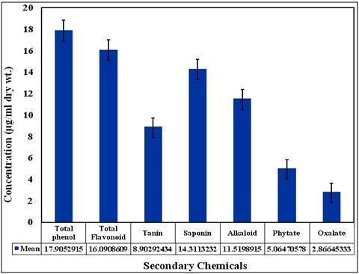

**Fig. 1:-Phytochemical variations of *Glycosmis pentaphylla* fruit epicarp extract (Mean ±5 observations).**

* 1. ***UV-VIS spectroscopy characteristics of AgNPs***

During the green synthesis of AgNPs through the fruit epicarp extract changes colour from green to brown as previously reported by researchers (Fig. 2) Parvekar et al, 2020 37. The brown colour due to the reduction of Ag+ confirms the formation of AgNPs and was characterized by UV-Vis Spectroscopy as in Roy and Barik, 2010. The reduction of pure silver ions (Ag+) was estimated by UV-Vis spectral analysis in the frequency range of 270 to 500 nm at room temperature and which was represented the peak at around 420-430 nm for a long time interval (10-300 minutes) specific for the synthesis of AgNPs with longer stability (Fig. 3). The band at 420 - 430 nm can be attributed to the property surface plasmon resonance (SPR) due to the oscillation of electrons (Mie scattering) for the strong interaction of light with the AgNPs. In both cases EtOH act as blank. The λmax of AgNPs was observed at around 430 nm whereas in EtOH extract it was at around 380 nm, respectively within the time span of 10-300 minutes. The UV-visible spectra showed absorption bands in the 350 to 550 nm region which confirms the formation of AgNPs 38, 39.

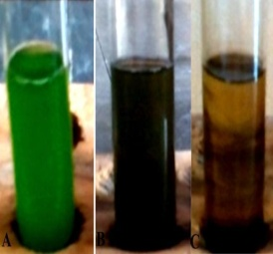

**Fig. 2: The colour changes from green (A) to brown (B and C) during the reaction of Ag+ into AgNPs due to the photochemical present in fruit epicarp extract of *Glycosmis pentaphylla.***

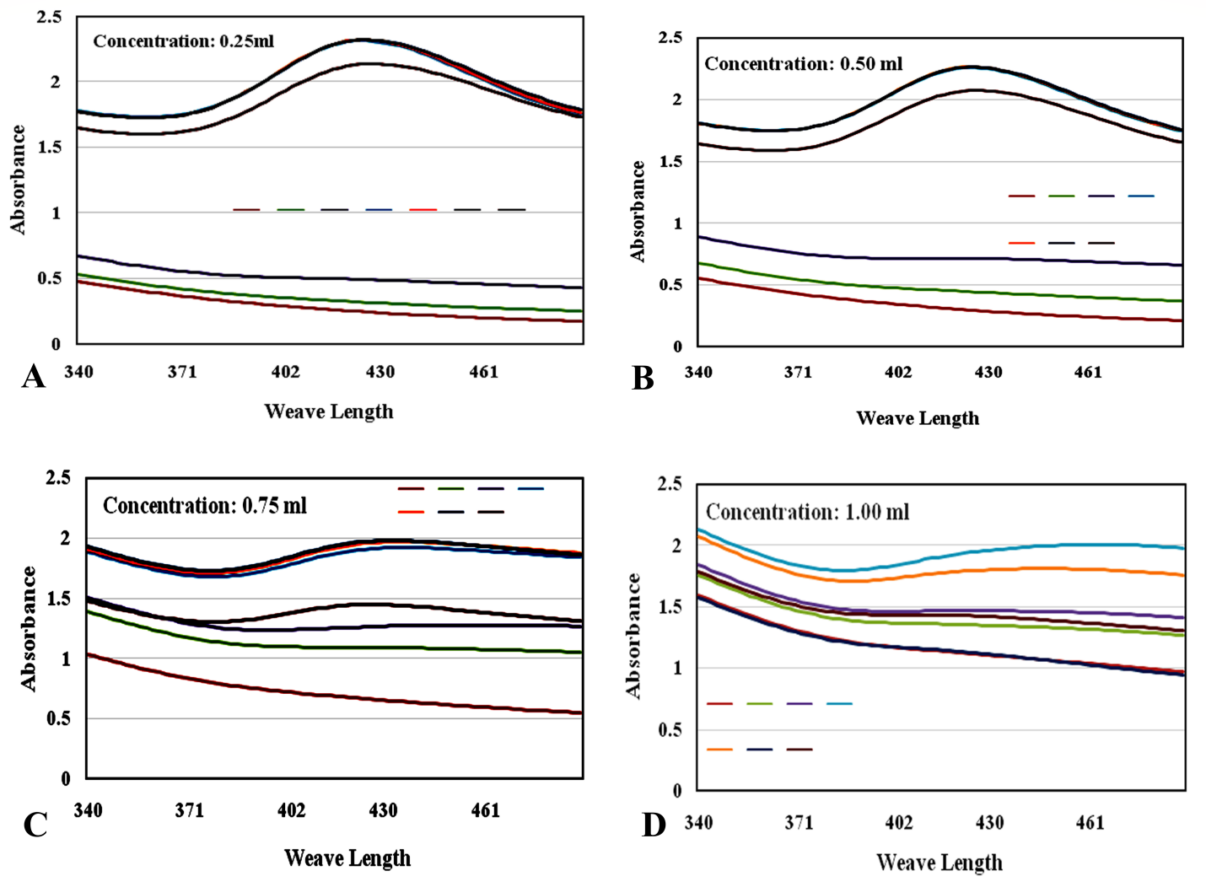

**Fig. 3:- UV-Vis absorption spectra recorded at different time intervals (10 min, 30 min, 1h, 24h, 48h, 72h) of AgNPs synthesized from fruit epicarp extract *Glycosmis pentaphylla* (Mean of 3 observations).**

* 1. ***SEM and TGA characteristics of AgNPs***

Microscopic surface features including morphology and particle size of synthesized AgNPs was assessed by SEM analysis. The SEM image provided roughly spherical topography of AgNPs was about 75±5 nm in size (Fig. 3). The SEM image also confirms that the synthesized nanoparticles are well separated with no aggregation (Fig. 4). TGA data of the synthesized AgNPs showed steady weight loss due to desorption of its bioorganic compounds with an increasing temperature range of 160–550˚C 19. Previously reported SEM images of AgNPs from different extracts showed spherical particles, aggregated spherical particles, irregularly shaped particles, and cubic particles 40, 41. The moderate particles sizes observed were 42, 41, 40, 43, 44, and 50 nm, for AgNPs synthesized by different biological extracts using water as a solvent. This observation aligns well with the previously reported particle sizes 40, 41, 45, 46, 47. In an article comparing the advantages and drawbacks of these methods and the applications of nanoparticles in various domains, a synthesis of chemical, physical, and biological methods for obtaining AgNPs of different shapes and dimensions (from 2 to 300 nm) was described 48.

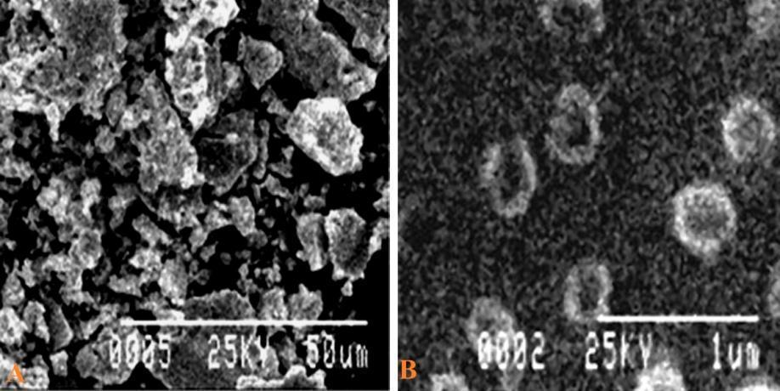

**Fig. 4:- The SEM images of AgNPs synthesized from fruit epicarp extract *Glycosmis pentaphylla* at 25.0 kV** × **1 k.**

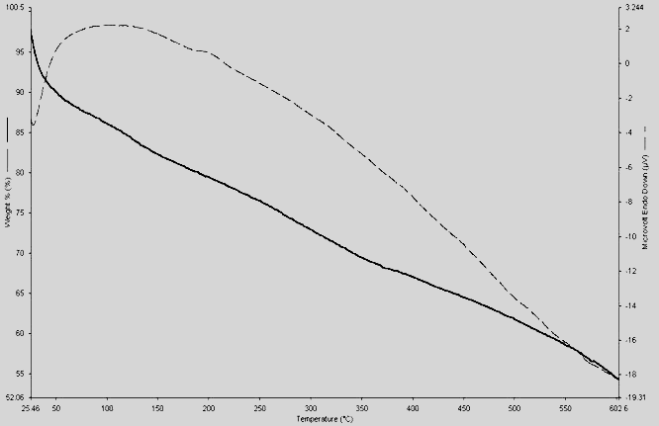

**Fig. 5:- TGA of the synthesized AgNPs showed steady weight loss within the temperature range of 160 –550˚C.**

* 1. ***Invitro antifungal potentiality of AgNPs***

The antimicrobial activities of AgNPs against various crop pathogenic funguses were investigated as shown in Fig. 6. The biosynthesized AgNPs inhibits the growth of *Fusarium oxysporum, Fusarium moliniliforme, Alternaria alternata, Colletotrichum lindemuthianum* and *Colletotrichum gloeosporioides.* Thus, AgNPs could be considered as excellent broad-spectrum antifungal agents for sustainable crop production and also could potentially be used widely in clinical applications against human pathogenic fungi. The various research reports of AgNPs synthesized from plants and microbes had broad range antifungal activity against *Fusarium oxysporum*, *Fusarium moniliforme*, *Fusarium tricinctum*, and *Alternaria* sp. by agar well diffusion method 49-51. The antifungal potentiality in other reports of AgNPs showed against crop pathogens such as *Aspergillus niger, Rhizoctonia solani, Curvularia lunata, Colletotrichum* sp. and *Fusarium* sp.52. 53.

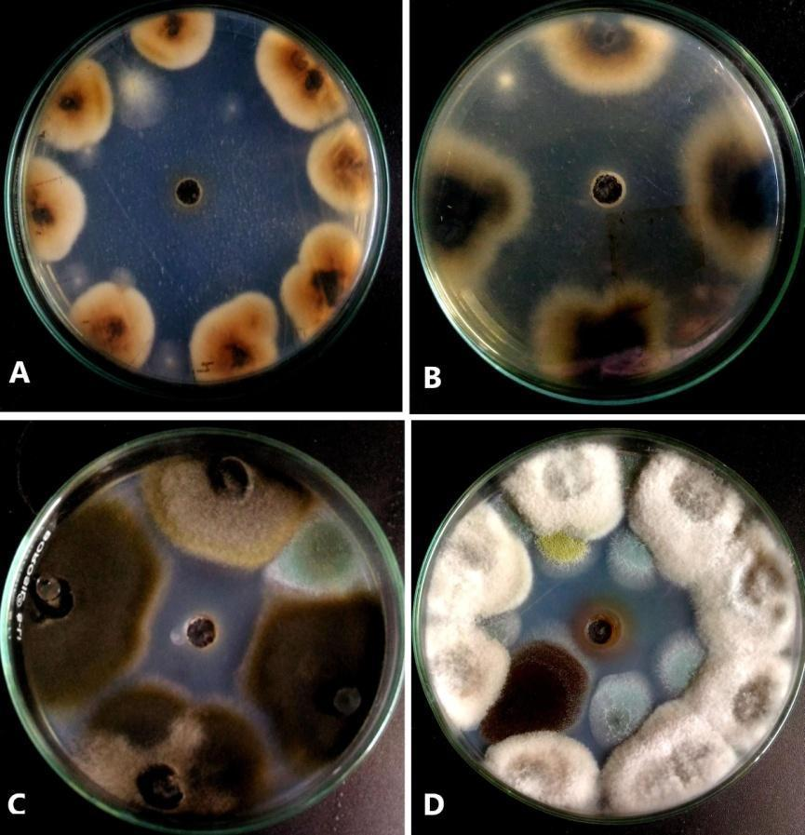

**Fig.6:- Antifungal activity of AgNPs in PDA media by agar well diffusion method; (A) *Colletitrichum lindemuthianum;* (B) *Alternaria alternata; (C) Colletotrichum gloeosporioides; (D)Fusarium moniliforme***

* 1. ***Determination of MIC and MFC of AgNPs***

The minimum inhibitory concentration and minimum fungicidal concentration of AgNPs forfive different fungal strains as shown in Table – 1. The results suggest that the plant synthesized AgNPs are capable of inhibiting crop fungi like *Fusarium oxysporum, Fusarium moniliforme ,Alternaria alternata, Colletotrichum lindemuthianum* and *Colletotrichum gloeosporioides.* The highest MIC values shown in *Alternaria alternata, Fusarium oxysporum, Fusarium moniliforme* was 6.2 µg/ml and the highest MFC values was 7.14 µg/ml. Green synthesized silver nanoparticles had antimicrobial effects against *A. flavus, F.oxysporum,* and *P. digitatum* on PDA in vitro. Inhibition (97.3%) was obtained against *A. flavus* treated with a 10 µg/ml concentration of silver nanoparticles and the minimal level of inhibition was found against *P. digitatum* and *F. oxysporum* with 2 µg/ml concentrations of AgNPs 54. This could be possible to adhere AgNPs to fungal hyphae and deactivate plant pathogenic fungi. DNA loses its ability to replicate upon treatment with Ag+ resulting in inactivated expression of ribosomal subunit proteins, as well as certain other cellular proteins and enzymes essential to ATP production 55, 56.

| **Table - 1:MIC and MFC values of synthesized AgNPs against different fungal pathogens** | | | | | | | | | | |
| --- | --- | --- | --- | --- | --- | --- | --- | --- | --- | --- |
| **Name of the crop pathogens** | **Concentration of AgNPs (µg/ml)** | | | | | | | | | |
| **50 µg/ml** | **25 µg/ml** | **16.66 µg/ml** | **12.5 µg/ml** | **10 µg/ml** | **8.33 µg/ml** | **7.14 µg/ml** | **6.2 µg/ml** | **5.55 µg/ml** | **5.26 µg/ml** |
| ***Alternaria alternata*** | **+** | **+** | **+** | **+** | **+** | **+** | **MFC** | **MIC** | **−** | **−** |
| ***Colletotrichum gloeosporioides*** | **+** | **+** | **+** | **+** | **+** | **+** | **+** | **MFC** | **MIC** | **−** |
| ***Colletotrichum***  ***lindemuthianum*** | **+** | **+** | **+** | **+** | **+** | **+** | **+** | **MFC** | **MIC** | **−** |
| ***Fusarium moniliforme*** | **+** | **+** | **+** | **+** | **+** | **+** | **MFC** | **MIC** | **−** | **−** |
| ***Fusarium oxysporum*** | **+** | **+** | **+** | **+** | **+** | **+** | **MFC** | **MIC** | **−** | **−** |
| *Here ‘+ʼ indicated the positive inhibition zone and ‘−ʼ indicated the absence of inhibition zone****.*** | | | | | | | | | | |

* 1. ***Antimicrobial Activity of  AgNPs***

The application of AgNPs against human pathogenic bacteria showed significant growth as shown in Fig. 7. The antibacterial activity was measured through the zone of inhibition against *B. subtilis* (18 mm), *S. typhimurium* (17.33 mm), *S. mutans* (17 mm) and *E. coli* (17 mm) which was shown in Fig. 8. It was observed that the AgNPs was a more potent antibacterial compound than other. The comparison of a single application of AgNPs , Streptomycin, Gentamicin and Ciprofloxacin against the Gram-positive and Gram-negative bacterial strains which was shown in Fig. 9. The results showed that antibiotics and AgNPs have more or less parallel potency by means of formation of inhibition zone (mm) by the application of the same volume (10 µl) and same concentration (6 µg/ml).The antimicrobial activity of silver nanoparticles was previously reported to penetrate the cell wall of bacteria and kill them57. Due to the presence of a thin peptidoglycan layer in cells of Gram, negative bacteria show potent higher than Gram positive 58. Anyhow, our study, carryout the new features of antibacterial.

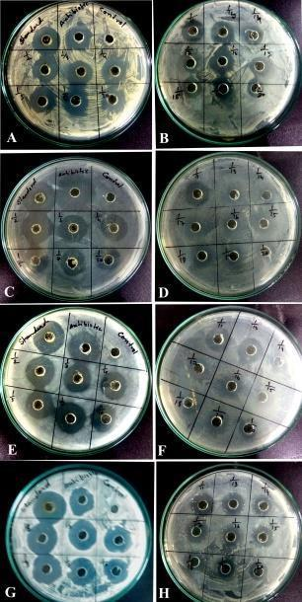

**Figure 7: Agar well diffusion assay of the AgNPs .(A-B) against *B. subtilis*; (C-D) against *S. mutans*; (E-F) against *E. coli*; (G-H) against *S. typhimurium*.**

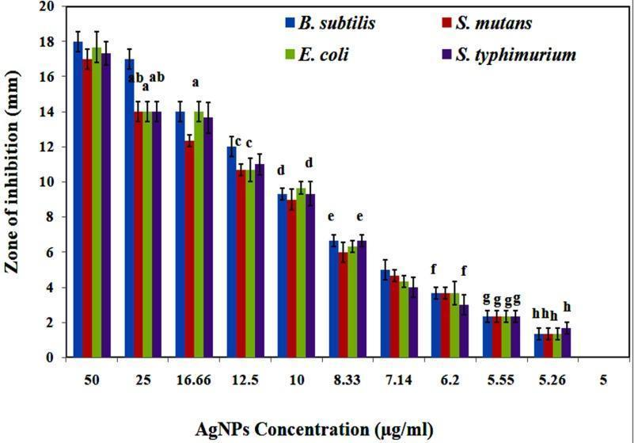

***The data are displayed as mean ± standard error. Bar with the same letters indicate no significant differences according to Tukey (HSD) test (P < 0.05). Here alphabets a, b, c, d, e, f, g, h indicates bar with******standard error.***

**Fig-8: Antibacterial assessment of the AgNPs. Here, the data were the average**

**diameter of inhibition zone of triplicate trials**

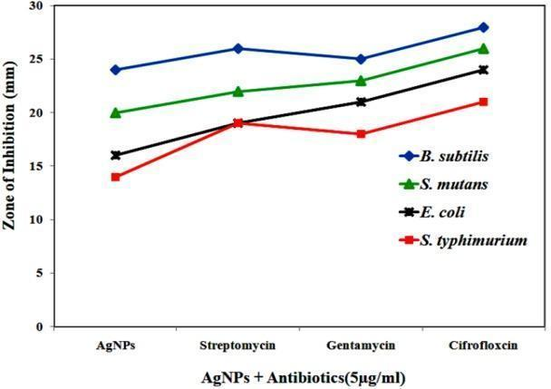

**Fig 9: Potency of antimicrobial activity of AgNPs, Streptomycin, Gentamycin and Ciprofloxacin against the Gram-positive and Gram-negative bacterial strains.**

* 1. ***Minimum Inhibitory Concentration (MIC) and Minimum Bactericidal Concentration (MBC)***

The results of Table 3 showed that the MIC values varied from 6~5 µg/ml. The MIC values for *B subtilis* and *E. coli* was 5 µg/ml and 5.26 µg/ml MIC values for *S. mutans* and *S. typhimurium* respectively. Similarly, the MBC value for *B. subtilis* and *E. coli* were 5.26 µg/ml and for *S. mutans* and *S. typhimurium*it was 5.55 µg/ml. From the above observations, it is very much clear that AgNPs have the highest antibacterial effect which causes the highest interaction with the bacterial cell wall. Similar observation on antibacterial activity was also observed by the previous studies 59. We found no particular trend of antibacterial effect for four pathogenic bacteria. Antibacterial activity of AgNPs was observed highest in Gram-negative bacteria than Gram-positive due to the presence of a thick peptidoglycan layer 60. Phytofabricated AgNPs with antimicrobial properties have also been investigated against different microbes which actually depend on size, shape, environmental conditions (pH, ionic strength) and capping agent 61. Recently, efficient antimicrobial activity of green AgNPs was observed against multi drug resistant (MDR) and highly pathogenic bacteria (*P. aeruginosa*, *S. aureus*, *S. typhi*, *S. epidermidis* and *E. coli*) 62 and fungi (*C. gloeosporioides*) 63. Our study shows that *S. mutans* (Gram positive) and *S. typhimurium* (Gram negative) were most sensitive which indicates the mode of action was not only affected by cell wall thickness of the bacteria. Ag+ release from AgNP is another reason for antibacterial activity. As the smaller AgNPs have the higher surface areas associated with the faster release of Ag+ 64 and exert higher toxicity. The high affinity of Ag+ towards protein thiol groups of respiratory enzymes inactivated enzymes even died out 65. AgNPs also plays an important role in biocompatibility as it controls the interaction of AgNP with a living organism.

| **Table -2: MIC and MBC values of synthesized AgNPs against different Bacterial pathogens.** | | | | | | | | | | | | |
| --- | --- | --- | --- | --- | --- | --- | --- | --- | --- | --- | --- | --- |
| **Sl. No.** | **Strains** | **AgNPs (100 µg/ml)** | | | | | | | | | | |
| **50 µg/ml** | **25 µg/ml** | **16.66 µg/ml** | **12.5 µg/ml** | **10 µg/ml** | **8.33 µg/ml** | **7.14 µg/ml** | **6.25 µg/ml** | **5.55 µg/ml** | **5.26 µg/ml** | **5 µg/ml** |
| **Gram-positive** | ***B. subtilis*** | + | + | + | + | + | + | + | + | + | MBC | MIC |
| ***S. mutans*** | + | + | + | + | + | + | + | + | MBC | MIC | − |
| **Gram negative** | ***E. coli*** | + | + | + | + | + | + | + | + | + | MBC | MIC |
| ***S. typhimurium*** | + | + | + | + | + | + | + | + | MBC | MIC | − |
| ***Here ‘+ʼ indicated the positive inhibition zone and ‘−ʼ indicated the absence of inhibition zone.*** | | | | | | | | | | | | |

* 1. ***Synergistic effect of AgNPs***

The combined effect of antibiotics and AgNPs against different human pathogenic bacteria showed in Table -3. The highest inhibition zone was observed in dual (AgNPs + antibiotic) application than single (AgNPs). The combined effect against bacteria increased the diameter of the inhibition zone that may be possible due to bonding between antibiotics and AgNPs as the antibiotics generally contain active groups like hydroxyl or amino, which bind AgNPs by chelation 67. The application of Streptomycin with AgNPs showed the highest increasing fold 38.24% against *E. coli* followed by 31.89%, 25%, 20% against *B. subtilis, S. mutans* and *S. typhimurium.* Similarly, the combined application of Ciprofloxacin showed the highest fold increase 30% against *B. subtilis* followed by 24.64%, 15.95% and 5.67 against *S. mutans* and *S. typhimurium*. When bacteria acquire antibacterial resistance, synergistic effect plays an important role as AgNPs and antibiotics kill bacteria in different mechanisms 67. Our study reveals that, synthesized AgNPs is able to decrease the concentration of Streptomycin and Cifrofloxcin against *S. mutans* & *S. typhimurium* with lowering the side effects and cost effectiveness of antibiotics.

| **Table -3: Synergistic effect of two antibiotics with AgNPs against *B. subtilis, S. mutans* and *E. coli, S. typhimurium*; FI-fold increase FI% = [(b − a)/a) × 100]** | | | | | | | | |
| --- | --- | --- | --- | --- | --- | --- | --- | --- |
| **Sample** | **Name of the Pathogens** | **Inhibition zone diameter (mm) for AgNPs** | **Inhibition zone diameter (mm) for Streptomycin (AB)** | | | **Inhibition zone diameter (mm) for Ciprofloxacin (AB)** | | |
| **Only AB (a)** | **AB+ AgNPs (b)** | **FI %** | **Only AB (a)** | **AB+ AgNPs (b)** | **FI %** |
| AgNPs | *B. subtilis* | 21.000 ± 0.577 | 24.000 ± 0.577 | 30.000af ± 0.577 | 25 | 23.333g ± 0.333 | 30.333a ± 0.333 | 30 |
| *S. mutans* | 20.333d ± 0.333 | 23.000be ± 0.577 | 30.333f ± 0.333 | 31.89 | 23.000bg ± 0.577 | 28.667h± 0.882 | 24.64 |
| *E. coli* | 20.000d ± 0.577 | 22.667 ± 0.333 | 31.333 ± 0.667 | 38.24 | 23.000g ± 0.577 | 26.667 ± 0.882 | 15.95 |
| *S. typhimurium* | 19.000 ± 0.577 | 23.333e ± 0.333 | 28.000c ± 0.577 | 20 | 22.667 ± 0.333 | 28.333ch ± 1.202 | 5.67 |

***The data are displayed as mean ± standard error according to Tukey (HSD) test (P <0.05)***

1. **CONCLUSION**

The biosynthesis of silver nanoparticles from different parts of plant is low cost, safe, environmentally friendly, less time consuming, and it provides effective satisfactory results without any hazardous chemicals involved. In the present study, AgNPs were successfully synthesized through the green technique at normal room temperature. The SEM studies confirmed that the concentration of the fruit epicarp extract is highly efficient in controlling the shape and size of AgNPs structures. TGA was detecting the steady weight loss due to desorption of its bioorganic compounds with increasing temperature. The synthesized AgNPs are lysis the cell wall integrity against pathogenic bacteria and few crop fungi. The applications of AgNPs and antibiotics together improved its efficiency to reduce the dose and also its cost. These results not only provide a new approach for integrative control of plant pathogens but also reduce or avoid the use of various drugs. From the application point of view, these AgNPs could be used as biofungicide for sustainable agriculture and biomedical use against human pathogenic bacteria in future studies.

1. **FUNDING ACKNOWLEDGMENT**

We are grateful to USIC department of the University of Burdwan and Department of Botany, Sreegopal Banerjee College for their help. The financial assistance provided by the University Grants Commission File No: PSW-029/14-15(ERO) and [F. No. PSW-025/13-14], New Delhi, Government of India is gratefully acknowledged.

1. **AUTHORS CONTRIBUTION STATEMENT**

Swapan Kumar Chowdhury designed the whole study including sample collection, antibacterial assay, antifungal assay, synergistic effect at Department of Botany, Sreegopal Banerjee College and prepared the manuscript. Nayan Roy conducted chemical analysis, synthesis of AgNPs, Characterization and prepared contribution part of manuscript. Indrani Mukherjeeprepared the part of the manuscript. All the authors read and approved the final version of the manuscript.

1. **CONFLICT OF INTEREST**

Conflict of interest declared none.

1. **REFERENCES**

1. Droby S. Improving quality and safety of fresh fruits and vegetables after harvest by the use of biocontrol agents and natural materials. Acta Hortic. 2006;(709):45-52. doi: [10.17660/ActaHortic.2006.709.5](https://doi.org/10.17660/ActaHortic.2006.709.5).

2. Eni. AO, Ibokunoluwa O, and Oranusi, U. Afr J Food Sci. 2010, Microbial quality of fruits and vegetables;4:291-6.

3. Kaweeteerawat C, Na Ubol P, Sangmuang S, Aueviriyavit S, Maniratanachote R. Mechanisms of antibiotic resistance in bacteria mediated by silver nanoparticles. J Toxicol Environ Health A. 2017;80(23-24):1276-89. doi: [10.1080/15287394.2017.1376727](https://doi.org/10.1080/15287394.2017.1376727), PMID [29020531](https://www.ncbi.nlm.nih.gov/pubmed/29020531).

4. Kavyashree D, Shilpa CJ, Nagabhushana H, Daruka PB, Sreelatha GL, Sharma SC, Ashoka S, Kumari AR, Premkumar HB. ZnO Superstructures as an antifungal for effective control of Malassezia furfur, dermatologically prevalent yeast: prepared by *Aloe vera* assisted combustion method. ACS Sustain Chem Eng. 2015;3(6):1066-80. doi: [10.1021/sc500784p](https://doi.org/10.1021/sc500784p).

5. Jogaiah S, Abdelrahman MKM, Hanumanthappa N, Tran LSP. *Ganoderma applanatum*-mediated green synthesis of silver nanoparticles: Structural characterization, and *in vitro* and *in vivo* biomedical and agrochemical properties, Arab. J Chem. 2019;12(7):1108-20. doi: [10.1016/j.arabjc.2017.12.002](https://doi.org/10.1016/j.arabjc.2017.12.002).

6. Mallmann EJJ, Cunha FA, Castro BNMF, Maciel AM, Menezes EA, Fechine PBA. Antifungal activity of silver nanoparticles obtained by green synthesis. Rev Inst Med Trop Sao Paulo. 2015;57(2):165-7. doi: [10.1590/S0036-46652015000200011](https://doi.org/10.1590/s0036-46652015000200011), PMID [25923897](https://www.ncbi.nlm.nih.gov/pubmed/25923897).

7. Salem W, Leitner DR, Zingl FG, Schratter G, Prassl R, Goessler W, Reidl J, Schild S. Antibacterial activity of silver and zinc nanoparticles against *Vibrio cholerae* and enterotoxic *Escherichia coli*. Int J Med Microbiol. 2015;305(1):85-95. doi: [10.1016/j.ijmm.2014.11.005](https://doi.org/10.1016/j.ijmm.2014.11.005), PMID [25466205](https://www.ncbi.nlm.nih.gov/pubmed/25466205).

8. Elgorban AM, El-Samawaty AEM, Yassin MA, Sayed SR, Adil SF, Elhindi KM, Bakri M, Khan M. Antifungal silver nanoparticles: synthesis, characterization and biological evaluation. Environ Biotechnol. 2016;30(1):56-62. doi: [10.1080/13102818.2015.1106339](https://doi.org/10.1080/13102818.2015.1106339).

9. Mei L, Lu Z, Zhang X, Li C, Jia Y. Polymer-Ag nanocomposites with enhanced antimicrobial activity against bacterial infection. ACS Appl Mater Interfaces. 2014;6(18):15813-21. doi: [10.1021/am502886m](https://doi.org/10.1021/am502886m), PMID [25170799](http://www.ncbi.nlm.nih.gov/pubmed/25170799).

10. Kumar SK, Prokhorov E, Hernández IM, Mota-Morales JD, Vázquez-Lepe M, Kovalenko Y, Sanchez IC, Luna BG. Chitosan/silver nanocomposites: Synergistic antibacterial action of silver nanoparticles and silver ions. Eur Polym J. 2015;67:242-51. doi: [10.1016/j.eurpolymj](https://doi.org/10.1016/j.eurpolymj). 2015.03.066.

11. Pavoski G, StammBaldisserotto DL, Maraschin T, Wentz Brum LF, dos Sannto C, dos Santosa JHZ, Brandelli A, Galland GB. Silver nanoparticles encapsulated in silica: Synthesis, characterization and application as antibacterial fillers in the ethylene polymerization. Eur Polym J. 2019;117:38-54. doi: [10.1016/j.eurpolymj](https://doi.org/10.1016/j.eurpolymj). 2019.04.055.

12. Wang L, Hu C, Shao L. The antimicrobial activity of nanoparticles: present situation and prospects for the future. Int J Nanomedicine. 2017;12:1227-49. doi: [10.2147/IJN.S121956](https://doi.org/10.2147/ijn.s121956), PMID [28243086](https://www.ncbi.nlm.nih.gov/pubmed/28243086).

13. Rauwel P, Rauwel E, Ferdov S, Singh MP. Silver nanoparticles: synthesis, properties, and applications. Adv Mater Sci Eng. 2015;2015:Article ID 624394, 2 pages. doi: [10.1155/2015/624394](https://doi.org/10.1155/2015/624394).

14. Gupta RK, Kumar V, Gundampati RK, Malviya M, Hasan SH, Jagannadham MV. Biosynthesis of silver nanoparticles from the novel strain of Streptomyces Sp. BHUMBU-80 with highly efficient electroanalytical detection of hydrogen peroxide and antibacterial activity. J Environ Chem Eng. 2017;5(6):5624-35. doi: [10.1016/j.jece.2017.09.029](https://doi.org/10.1016/j.jece.2017.09.029).

15. Loo YY, Rukayadi Y, Nor-Khaizura MAR, Kuan CH, Chieng BW, Nishibuchi M, Radu S. *In vitro* antimicrobial activity of green synthesized silver nanoparticles against selected Gram-negative food borne pathogens. Front Microbiol. 2018;9:1555. doi: [10.3389/fmicb.2018.01555](https://doi.org/10.3389/fmicb.2018.01555), PMID [30061871](https://www.ncbi.nlm.nih.gov/pubmed/30061871).

16. Franci G, Falanga A, Galdiero S, Palomba L, Rai M, Morelli G, Galdiero M. Silver nanoparticles as potential antibacterial agents. Molecules. 2015;20(5):8856-74. doi: [10.3390/molecules20058856](https://doi.org/10.3390/molecules20058856), PMID [25993417](https://www.ncbi.nlm.nih.gov/pubmed/25993417).

17. Guilger-Casagrande M, de Lima R. Synthesis of silver nanoparticles mediated by fungi: a review. Front Bioeng Biotechnol. 2019;7:287. doi: [10.3389/fbioe.2019.00287](https://doi.org/10.3389/fbioe.2019.00287), PMID [31696113](https://www.ncbi.nlm.nih.gov/pubmed/31696113).

18. Hamouda RA, Hussein MH, Abo-Elmagd RA, Bawazir SS. Synthesis and biological characterization of silver nanoparticles derived from the cyanobacterium, *Oscillatori alimnetica*. Sci Rep. 2019;9(1):13071. doi: [10.1038/s41598-019-49444-y](https://doi.org/10.1038/s41598-019-49444-y), PMID [31506473](https://www.ncbi.nlm.nih.gov/pubmed/31506473).

19. Roy N, Barik A. Green synthesis of silver nanoparticles from the unexploited weed resources. Int J Nanotechnol Appl. 2010;4(2):95-101.

20. Roy N, Nag D, Chowdhury SK. Bottom up phytofabrication of silver nanoparticles and their antimicrobial activity, biomaterial and biomedicine. 2015;5(37):1-14. doi: [10.5376/bb.2015.05.0037](https://doi.org/10.5376/bb.2015.05.0037).

21. Pirtarighat S, Ghannadnia M, Baghshahi S. Green synthesis of silver nanoparticles using the plant extract of *Salvia spinosa* grown in vitro and their antibacterial activity assessment. J Nanostruct Chem. 2019;9(1):1-9. doi: [10.1007/s40097-018-0291-4](https://doi.org/10.1007/s40097-018-0291-4).

22. Bray HG, Thorpe WV. Analysis of phenolic compounds of interest in metabolism. Method Biochem Anal. 1954;1:27-52. doi: [10.1002/9780470110171.ch2](https://doi.org/10.1002/9780470110171.ch2), PMID [13193524](https://www.ncbi.nlm.nih.gov/pubmed/13193524).

23. Zhishen J, Mengcheng T, Jianming W. Research on antioxidant activity of flavonoids from natural materials. Food Chem. 1999;64(4):555-9. doi: [10.1016/S0308-8146(98)00102-2](https://doi.org/10.1016/s0308-8146(98)00102-2).

24. Trease GE, Evans WC. Textbook of pharmacognosy. 12th ed. London: BallieseTindall and Company Publisher; 1983. p. 343-83.

25. Harborne B. Phytochemical methods: a guide to modern techniques of plant analysis. 2nd ed. New York: Chapman & Hall; 1973. p. 88-185.

26. Reddy MB, Love M. The impacts of food processing on the nutritional quality of vitamins and minerals. Adv Exp Med Biol. 1999;459:99-106. doi: [10.1007/978-1-4615-4853-9_7](https://doi.org/10.1007/978-1-4615-4853-9_7), PMID [10335371](https://www.ncbi.nlm.nih.gov/pubmed/10335371).

27. Day RA, Underwood AL. Quantitative analysis. New Delhi, India: Prentice Hall publication; 1986.

28. Ahmed S, Saifullah, Ahmad M, Swami BL, Ikram S. Green synthesis of silver nanoparticles using Azadirachta indica aqueous leaf extract. J Radiat Res Appl Sci. 2016;9(1):1-7. doi: [10.1016/j.jrras.2015.06.006](https://doi.org/10.1016/j.jrras.2015.06.006).

29. Jain S, Mehata MS. Medicinal plant leaf extract and pure flavonoid mediated green synthesis of silver nanoparticles and their enhanced antibacterial property. Sci Rep. 2017;7(1):15867. doi: [10.1038/s41598-017-15724-8](https://doi.org/10.1038/s41598-017-15724-8), PMID [29158537](https://www.ncbi.nlm.nih.gov/pubmed/29158537).

30. Rautela A, Rani J, Debnath. (Das), M. Green synthesis of silver nanoparticles from *Tectona grandis* seeds extract: characterization and mechanism of antimicrobial action on different microorganisms. J Anal Sci Technol. 2019;10:5. doi: [10.1186/s40543-018-0163-z](https://doi.org/10.1186/s40543-018-0163-z).

31. Loo YY, Rukayadi Y, Nor-Khaizura MA, Kuan CH, Chieng BW, Nishibuchi M, Radu S. In vitro antimicrobial activity of green synthesized silver nanoparticles against selected Gram-negative foodborne pathogens. Front Microbiol. 2018;9:1555. doi: [10.3389/fmicb.2018.01555](https://doi.org/10.3389/fmicb.2018.01555), PMID [30061871](https://www.ncbi.nlm.nih.gov/pubmed/30061871).

32. Lotfy WA, Alkersh BM, Sabry SA, Ghozlan HA. Biosynthesis of Silver Nanoparticles by *Aspergillus terreus*: Characterization, Optimization, and Biological Activities. Front Bioeng Biotechnol. 2021;9:633468. doi: [10.3389/fbioe.2021.633468](https://doi.org/10.3389/fbioe.2021.633468).

33. Sanchooli N, Saeidi S, Barani HK, Sanchooli E. *In vitro* antibacterial effects of silver nanoparticles synthesized using *Verbena officinalis* leaf extract on *Yersinia ruckeri*, *Vibrio cholerae* and *Listeria monocytogenes*. Iran J Microbiol. 2018;10(6):400-8. PMID [30873268](https://www.ncbi.nlm.nih.gov/pubmed/30873268).

34. Thomas R, Nair AP, Kr S, Mathew J, Ek R. Antibacterial activity and synergistic effect of biosynthesized AgNPs with antibiotics against multidrug-resistant biofilm-forming coagulase-negative staphylococci isolated from clinical samples. Appl Biochem Biotechnol. 2014;173(2):449-60. doi: [10.1007/s12010-014-0852-z](https://doi.org/10.1007/s12010-014-0852-z), PMID [24699812](http://www.ncbi.nlm.nih.gov/pubmed/24699812).

35. Vijayakumar S, Krishnakumar C, Arulmozhi P, Mahadevan S, Parameswari N. Biosynthesis, characterization and antimicrobial activities of zinc oxide nanoparticles from leaf extract of *Glycosmis pentaphylla* (Retz.) DC. Microb Pathog. 2018;116:44-8. doi: [10.1016/j.micpath.2018.01.003](https://doi.org/10.1016/j.micpath.2018.01.003), PMID [29330059](https://www.ncbi.nlm.nih.gov/pubmed/29330059).

36. Zar JH. Biostatistical analysis. Englewood Cliffs: Prentice Hall; 1999.

37. Parvekar P, Palaskar J, Metgud S, Maria R, Dutta S. The minimum inhibitory concentration (MIC) and minimum bactericidal concentration (MBC) of silver nanoparticles against *Staphylococcus aureus*. Biomater Investig Dent. 2020;7(1):105-9. doi: [10.1080/26415275.2020.1796674](https://doi.org/10.1080/26415275.2020.1796674), PMID [32939454](https://www.ncbi.nlm.nih.gov/pubmed/32939454).

38. Sastry M, Mayya KS, Bandyopadhyay K. PH dependent changes in the optical properties of carboxylic acid derivatized silver colloidal particles. Colloids Surf A Physicochem Eng Asp. 1997;127(1-3):221-8. doi: [10.1016/S0927-7757(97)00087-3](https://doi.org/10.1016/s0927-7757(97)00087-3).

39. Sastry M, Patil V, Sainkar SR. Electrostatically controlled diffusion of carboxylic acid derivatized silver colloidal particles in thermally evaporated fatty amine films. Phys Chem. 1998;102:1404-10. doi: [10.1021/jp9719873](https://doi.org/10.1021/jp9719873).

40. Birla SS, Gaikwad SC, Gade AK, Rai MK. Rapid synthesis of silver nanoparticles from *Fusarium oxysporum* by optimizing physicocultural conditions. Sci World J, vol. 2013;2013:Article ID 796018. doi: [10.1155/2013/796018](https://doi.org/10.1155/2013/796018), PMID [24222751](https://www.ncbi.nlm.nih.gov/pubmed/24222751).

41. Elgorban AM, Al-Rahmah AN, Sayed SR, Hirad A, Mostafa AA-F, Bahkali AH. Antimicrobial activity and green synthesis of silver nanoparticles using *Trichoderma viride*. Biotechnol Biotechnol Equip. 2016;30(2):299-304. doi: [10.1080/13102818.2015.1133255](https://doi.org/10.1080/13102818.2015.1133255).

42. Clement JL, Jarrett PS. Antibacterial silver. Met Based Drugs. 1994;1(5-6):467-82. doi: [10.1155/MBD.1994.467](https://doi.org/10.1155/MBD.1994.467), PMID [18476264](https://www.ncbi.nlm.nih.gov/pubmed/18476264).

43. Anandalakshmi K, Venugobal J, Ramasamy V. Characterization of silver nanoparticles by green synthesis method using *Pedalium murex* leaf extract and their antibacterial activity. Appl Nanosci. 2016;6(3):399-408. doi: [10.1007/s13204-015-0449-z](https://doi.org/10.1007/s13204-015-0449-z).

44. Kim KJ, Sung WS, Suh BK, Moon SK, Choi JS, Kim JG, Lee DG. Antifungal activity and mode of action of silver nano-particles on *Candida albicans*. Biometals. 2009;22(2):235-42. doi: [10.1007/s10534-008-9159-2](https://doi.org/10.1007/s10534-008-9159-2), PMID [18769871](https://www.ncbi.nlm.nih.gov/pubmed/18769871).

45. Kasithevar M, Saravanan M, Prakash P et al. Green synthesis of silver nanoparticles using *Alysicar pusmonilifer* leaf extract and its antibacterial activity against MRSA and CoNS isolates in HIV patients. J Interdiscip Nanomed. 2017.View at: Publisher Site | Google Scholar;2(2):131-41. doi: [10.1002/jin2.26](https://doi.org/10.1002/jin2.26).

46. Lee SW, Chang SH, Lai YS, Lin CC, Tsai CM, Lee YC, Chen JC, Huang CL. Effect of temperature on the growth of silver nanoparticles using plasmon-mediated method under the irradiation of green LEDs. Materials (Basel). 2014;7(12):7781-98. doi: [10.3390/ma7127781](https://doi.org/10.3390/ma7127781), PMID [28788275](https://www.ncbi.nlm.nih.gov/pubmed/28788275).

47. Zada S, Ahmad A, Khan S et al. Biogenic synthesis of silver nanoparticles using extracts of *Lepto* *Lyngbya* JSC-1 that induce apoptosis in HeLa cell line and exterminate pathogenic bacteria. Artif Cells Nanomed Biotechnol. 2018.View at: Publisher Site | Google Scholar;46(3):S471-80.

48. Tripathi RM, Gupta RK, Shrivastav A, Singh MP, Shrivastav BR, Singh P. *Trichoderma koningii* assisted biogenic synthesis of silver nanoparticles and evaluation of their antibacterial activity. Adv Nat Sci Nanosci Nanotechnol. 2013;4(3):Article ID 035005.. doi: [10.1088/2043-6262/4/3/035005](https://doi.org/10.1088/2043-6262/4/3/035005).

49. Devi JS, Bhimba BV. Antibacterial and antifungal activity of silver nanoparticles synthesized using *Hypnea muciformis*. Biosci Biotechnol Res Asia. 2014;11(1):235-8. doi: [10.13005/bbra/1260](https://doi.org/10.13005/bbra/1260).

50. Mendes JE, Abrunhosa L, Teixeira JE, De Camargo ER, De Souza CP, Pessoa JDC. Antifungal activity of silver colloidal nanoparticles against phytopathogenic fungus (*Phomopsis* sp.) in soybean seeds. Int J Biol Vet Agric Food Eng. 2014;8(9):928-33.

51. Bera RK, Mandal SM, Raj CR. Antimicrobial activity of fluorescent Ag nanoparticles. Lett Appl Microbiol. 2014;58(6):520-6. doi: [10.1111/lam.12222](https://doi.org/10.1111/lam.12222), PMID [24460988](https://www.ncbi.nlm.nih.gov/pubmed/24460988).

52. Balakumaran MD, Ramachandran R, Kalaichelvan PT. Exploitation of endophytic fungus, *Guignardiama ngiferae* for extracellular synthesis of silver nanoparticles and their in vitro biological activities. Microbiol Res. 2015;178:9-17. doi: [10.1016/j.micres.2015.05.009](https://doi.org/10.1016/j.micres.2015.05.009), PMID [26302842](https://www.ncbi.nlm.nih.gov/pubmed/26302842).

53. Al-Zubaidi S, Al-Ayafi A, Abdelkader H. Biosynthesis, characterization and antifungal activity of silver nanoparticles by *Aspergillus niger* isolate. J Nanotechnol Res. 2019;01(1):023-36. doi: [10.26502/jnr.2688-8521002](https://doi.org/10.26502/jnr.2688-8521002).

54. Abdelkader H, Alzahrani H, Al-Ayafi A, Al-Mulah H, Al-Zubaidi S. Green synthesis, Characterization and antimicrobial activity of biosynthesized Silver Nanoparticles using *Ziziphus spina-christi* leaf extracts. AdvMicrob. Resources. 2019;3:010.

55. Feng QL, Wu J, Chen GQ. A mechanistic study of the antibacterial effect of silver ions on *Escherichia coli* and *Staphylococcus aureus*. J Biomed Mater Res. 2000;52:662-8;2-3, doi: [10.1002/1097-4636](https://doi.org/10.1002/1097-4636), PMID [20001215](http://www.ncbi.nlm.nih.gov/pubmed/20001215) 52:4 <662:: AID-JBM10>3.0.CO.

56. Yamanaka M, Hara K, Kudo J. Bactericidal actions of a silver ion solution on *Escherichia coli*, studied by energy filtering transmission electron microscopy and proteomic analysis. Appl Environ Microbiol. 2005;71(11):7589-93. doi: [10.1128/AEM.71.11.7589-7593.2005](https://doi.org/10.1128/aem.71.11.7589-7593.2005), PMID [16269810](https://www.ncbi.nlm.nih.gov/pubmed/16269810).

57. Leung YH, Ng AM, Xu X, Shen Z, Gethings LA, Wong MT, Chan CM, Guo MY, Ng YH, Djurišić AB, Lee PK, Chan WK, Yu LH, Phillips DL, Ma AP, Leung FC. Mechanisms of antibacterial activity of MgO: non-ROS mediated toxicity of MgO nanoparticles towards *Escherichia coli*. Small. 2014;10(6):1171-83. doi: [10.1002/smll.201302434](https://doi.org/10.1002/smll.201302434), PMID [24344000](https://www.ncbi.nlm.nih.gov/pubmed/24344000).

58. Alsammarraie FK, Wang W, Zhou P, Mustapha A, Lin M. Green synthesis of silver nanoparticles using turmeric extracts and investigation of their antibacterial activities. Colloids Surf B Biointerfaces. 2018;171:398-405. doi: [10.1016/j.colsurfb.2018.07.059](https://doi.org/10.1016/j.colsurfb.2018.07.059), PMID [30071481](https://www.ncbi.nlm.nih.gov/pubmed/30071481).

59. Griffith M, Udekwu KI, Gkotzis S, Mah T-F, Alarcon EI. Anti-microbiological and anti-infective activities of silver. Engineering Materials. 2015:127-46. doi: [10.1007/978-3-319-11262-6_6](https://doi.org/10.1007/978-3-319-11262-6_6).

60. Cui H, Zhang C, Li C, Lin L. Antimicrobial mechanism of clove oil on *Listeria monocytogenes*. Food Control. 2018;94:140-6. doi: [10.1016/j.foodcont.2018.07.007](https://doi.org/10.1016/j.foodcont.2018.07.007).

61. Kim SW, Jung JH, Lamsal K, Kim YS, Min JS, Lee YS. Antifungal effects of silver nanoparticles (AgNPs) against various plant pathogenic fungi. Mycobiology. 2012;40(1):53-8. doi: [10.5941/MYCO.2012.40.1.053](https://doi.org/10.5941/myco.2012.40.1.053), PMID [22783135](https://www.ncbi.nlm.nih.gov/pubmed/22783135).

62. Singh K, Panghal M, Kadyan S, Chaudhary U, Yadav JP. Antibacterial activity of synthesized silver nanoparticles from *Tinospora cordifolia* against multi drug resistant strains of *Pseudomonas aeruginosa* isolated from burn patients. J Nanomed Nanotechnol. 2014;5:192. doi: [10.4172/2157-7439.1000192](https://doi.org/10.4172/2157-7439.1000192).

63. Chodappa P, Gowda S, Chethana CS, Madhura S. Atifungal activity of chitosan-silver nanoparticle composite against *Colletotrichum gloeosporioides* associated with mango anthracnose. Asian J Microb Res. 2014;8(17):1803-12. doi: [10.5897/AJMR2013.6584](https://doi.org/10.5897/ajmr2013.6584).

64. Sotiriou GA, Pratsinis SE. Antibacterial activity of nanosilver ions and particles. Environ Sci Technol. 2010;44(14):5649-54. doi: [10.1021/es101072s](https://doi.org/10.1021/es101072s), PMID [20583805](https://www.ncbi.nlm.nih.gov/pubmed/20583805).

65. Liau SY, Read DC, Pugh WJ, Furr JR, Russell AD. Interaction of silver nitrate with readily identifiable groups: relationship to the antibacterial action of silver ions [lett]. Lett Appl Microbiol. 1997;25(4):279-83. doi: [10.1046/j.1472-765X.1997.00219.x](https://doi.org/10.1046/j.1472-765x.1997.00219.x), PMID [9351278](https://www.ncbi.nlm.nih.gov/pubmed/9351278).

66. Batarseh KI. Anomaly and correlation of killing in the therapeutic properties of silver (I) chelation with glutamic and tartaric acids. J Antimicrob Chemother. 2004;54(2):546-8. doi: [10.1093/jac/dkh349](https://doi.org/10.1093/jac/dkh349), PMID [15243026](https://www.ncbi.nlm.nih.gov/pubmed/15243026).

67. Li P, Li J, Wu C, Wu Q, Li J. Synergistic antibacterial effects of β-lactam antibiotic combined with silver nanoparticles. Nanotechnology. 2005;16(9):1912-7. doi: [10.1088/0957-4484/16/9/082](https://doi.org/10.1088/0957-4484/16/9/082).

OTHER COMMENTS

1. **CONTENT IN THE SUB HEADING**

* No subheadings should have very less content. At least ensure that all the subheadings should at least have 60 words.

1. **FOR PLANT OR PHYTO CHEMICAL STUDY OR ANY RELEVANT STUDY**

* For plant or phyto chemical study or any relevant study, plant material should be authenticated by suitable botanist or Pharmacognosist or phyto chemistry
* Authentication done by ?whom ?? ( For Plant )
* Example

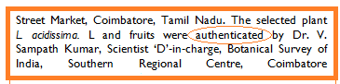

1. **For studies on specific animals**

* For studies on specific animals such as fishes, nematodes, insects etc, kindly provide authentication by zoologist for their zoological name.

1. **Ethical Committee Approval for Animals:**

* Kindly ensure that you include ethical committee approval for your animal study with registration or reference number. See the following examples,
* **Examples:**

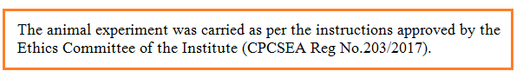

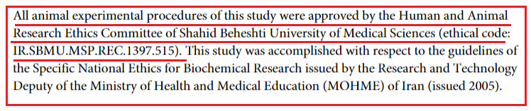

1. **Ethical committee approval for the Patient/human testing**

If your paper is related to patients or human testing , kindly include the Institutional permission statement and / or Human Ethical approval committee reference number for your study in the materials and methods. Mention which protocol was followed (Helinsky declaration or any other ) for conduction of the study .Also ensure and include appropriate sentence for getting a written patients consent for this study. See some of the following examples,

**Examples**

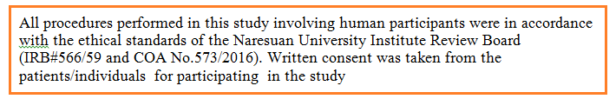

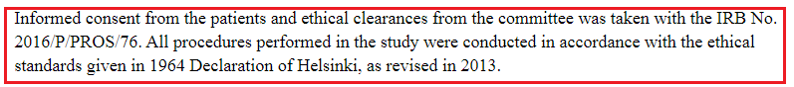

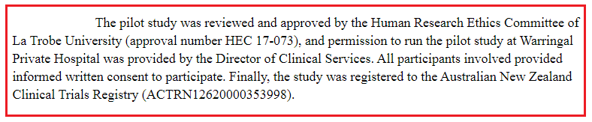

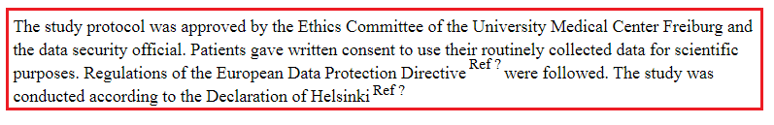

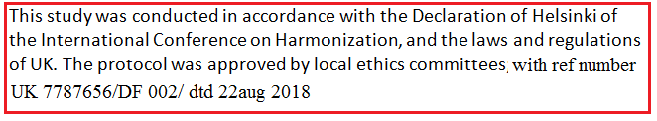

1. **INCLUSION AND EXCLUSION CRITERIA**
   * + For patients or treatments using humans you need to provide INCLUSION CRITERIA and EXCLUSION CRITERIA

The following link will give some idea about inclusion and exclusion criteria**,**

<https://en.wikipedia.org/wiki/Inclusion_and_exclusion_criteria>

<http://researcharticles.com/index.php/inclusion-and-exclusion-criteria-in-research/>

<https://libguides.city.ac.uk/postgraduate_research/criteria>

<https://media.tghn.org/articles/trialprotocoltool/SOURCE/Checklist/StudyPop/Inclusion%20and%20Exclusion.html>

**Example**

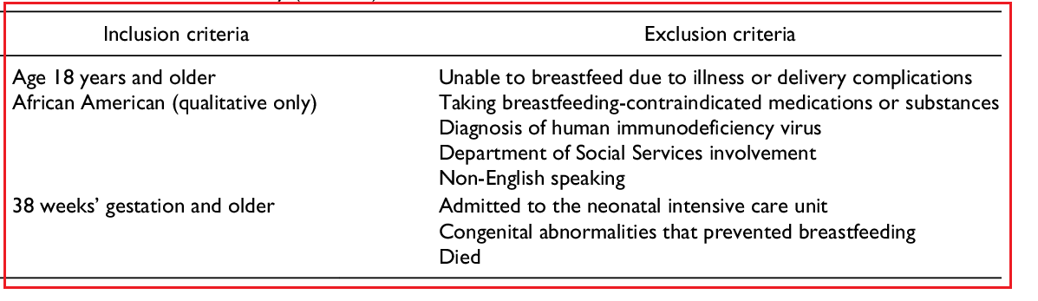

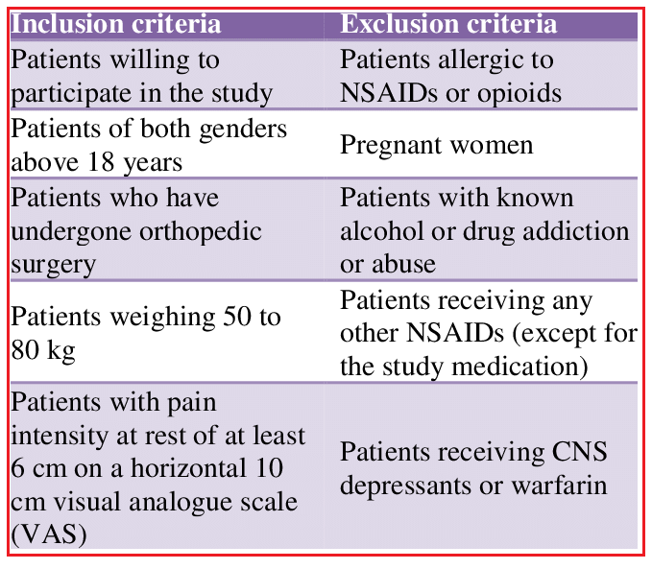

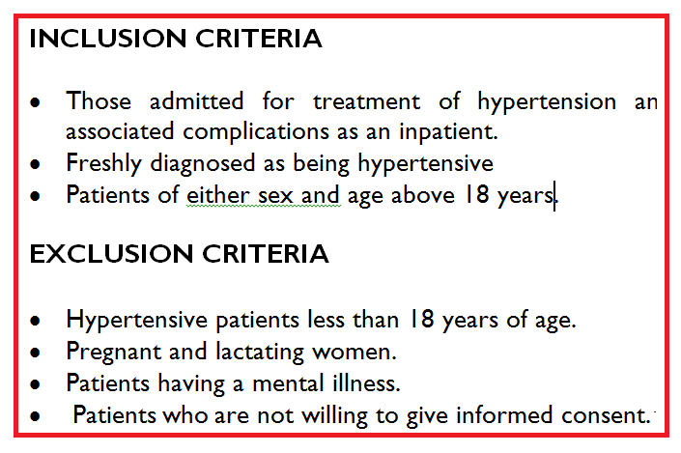

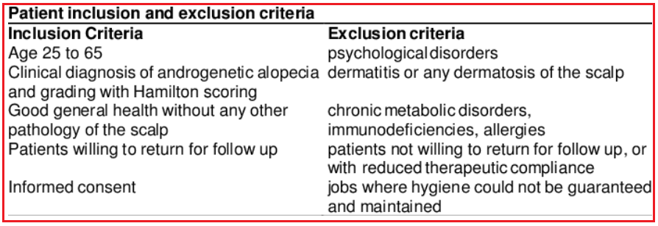

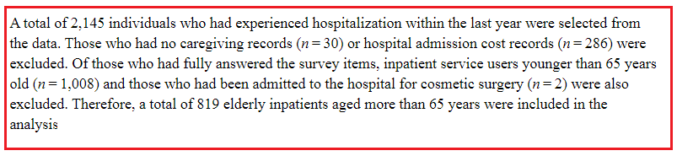

1. Placement of Tables/Figures/graphs at appropriate **places**

* All figures should be clear (not less than 300 dpi)
* Place all your tables/figures/graphs at or nearby the places were you are explaining or mentioning them .

1. **Number of References**

* There should be minimum 25 references and atleast 5 references should be of recent references

1. **Discussion:**

* Each and every sentences mentioning any earlier studies for discussing for your results should have respective reference number citation. Results should be discussed in support of citing references . Try to cite many references in support of your result interpretations from your result. Ensure that you have atleast 15 references cited in the discussion . See the following example

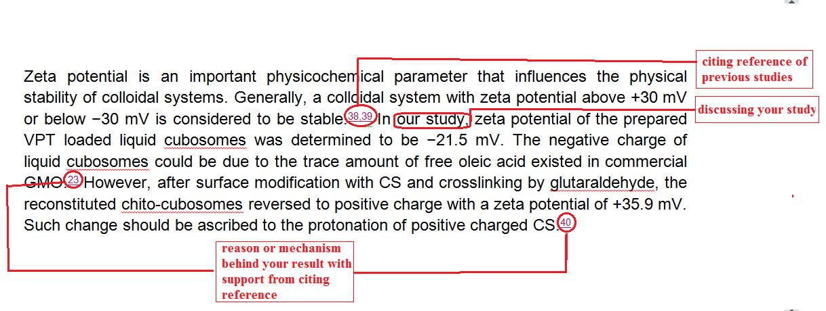

For any querry or help or assistance kindly [contact us](https://ijpbs.net/contact.html)